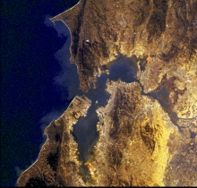
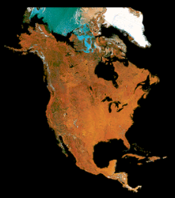
Geography Lab
C.J. Cox, Instructor
Sierra College Name ____________________
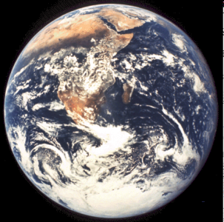

WEEK #7

REMOTE SENSING

Using the CD entitled “Small Blue Planet” Real Picture
World Atlas, complete the following exercise.

From the main menu of the four rotating globes, explore the left globe that will take you to the chronosphere (time zone program).

CHRONOSPHERE

1. Explore the chronosphere. By moving the arrow over the button you will learn what each button does. Move the time zone marker to your favored locations and determine what time it is for various parts of the world right now.

Using the autopilot (recycle symbol) you can fast-forward the time. Note the changes to the day/night as well. You may also wish to add the sub-solar point to see where the sun is directly overhead during times of the year.

Lastly note the changes of the circle of illumination on the globe.

What does the chronosphere show? __________________________________________________________________

INFRARED PICTURE GLOBE

Return to the main menu of the four rotating globes. Proceed to the infrared picture globe and explore the continents in pictures. Click the information text button for information on the images. Zoom in as close as your can. Be sure you do not miss Antarctica.

2. What is infrared? ____________________________________________________

What is it used for? ______________________________

MEASURING DISTANCES

Continuing to use the infrared images, go to California’s Central Valley. Zoom in as
close as you can.

3. Using the measuring tool, how far is it from Lake Tahoe to Mono Lake using a straight line. Measure from the middle of each lake. ____________ miles

4. Using the measuring tool again, how far is it from the Sutter Buttes to Monterey Bay? ______miles.

DIGITAL LATITUDE & LONGITUDE

Remaining on the infrared photos of California, note that the specific coordinates change as you move the cursor.

5. What is the latitude & longitude of Lake Tahoe? ____________________

6. What is the latitude & longitude of the San Francisco Bay? ______________

RELIEF IMAGES

Return to the main menu of the four globes. Click on the globe furthest to the right that shows relief maps and satellite pictures from around the world. Using the information text button answer the following question.

7. How was this relief image generated?

SATELLITE PHOTOS

Stay in the relief image section and go to the west coast of the US, specifically to the Bay Area. Click on the button below with the red dot. Click on the images associated with the red dots. Using the text information text button and the associated photo of San Francisco answer the following question.

8. What are two primary faults of San Francisco? ______________ and _________.

SATELLITE IMAGES

Return to the main menu of the four globes. Click on the remote sensing images below the globes. Examine some of the satellite gallery image types. Click on the button labels and hold down for an explanation of the type of remote sensing used. List these below.

- AVHRR – NOAA Weather Satellite Radiometer Images

b. .__________________________________________________________

c ._________________________________________________________

d._________________________________________________________

e..__________________________________________________________

f.__________________________________________________________

Maps & miscellaneous

AVHRR
Open the AVHRR section of photos and examine several of interest to you. You may wish to use the magnifying glass for more detail. Open the Middle East photo and examine the Nile delta and the superimposed country lines.

NASA AIRCRAFT
Return to the Satellite Gallery Menu and continue to the NASA Aircraft images. Forward to Niagara Falls in Oblique. Use the magnifying glass to examine the falls. Open the description of the image and answer the following question.

9. How high is the American Fall? _____________

What does the red color show in this image? ________________

EOSAT AND TM
Return to the Satellite Gallery Menu and open the EOSAT images. Forward to the image of Salt Lake. Note the different color waters.

10. What do colors of the water indicate?
__________________________________________

MSS
Return to the Satellite Gallery Menu and open the Multispectral Spectral Scanner. Forward to and view the Grand Canyon and the Mississippi Delta, using the magnifying glass.

NASA SSEOP
Return to the Satellite Gallery Menu and open the Space Shuttle Photos. Forward through the 100 or so images, and examine those of interest using the magnifying glass. (Be sure you don’t miss the “atmospheric profile”, “worlds rooftop” and some of the impressive weather elements of hurricanes, and thunderstorms.

11. What are some of the interesting items photographed by the space shuttle?

__________________________ __________________________

__________________________ __________________________

NIGHT SCANNERS
Return to the Satellite Gallery Menu and open the DMSP collection.

12. Why is the image of Antarctica so light? _________________________

What types of applications do these night photos have? ________________

If time allows continue to explore the Maps and Miscellaneous sections, including the Hammond map and the relief maps of the Miscellaneous section.

