Geography Lab Name _______________

Sierra College

C.J. Cox, Instructor

WEEK #2
CONSTRUCTING A LARGE OUTDOOR MAP

Construction Materials

Chalk Hammers Cups for chalk
4 tape measures String Scissors
Stakes Masking Tape Compass & Distance Measure
Orange or yellow ribbon for map perimeters

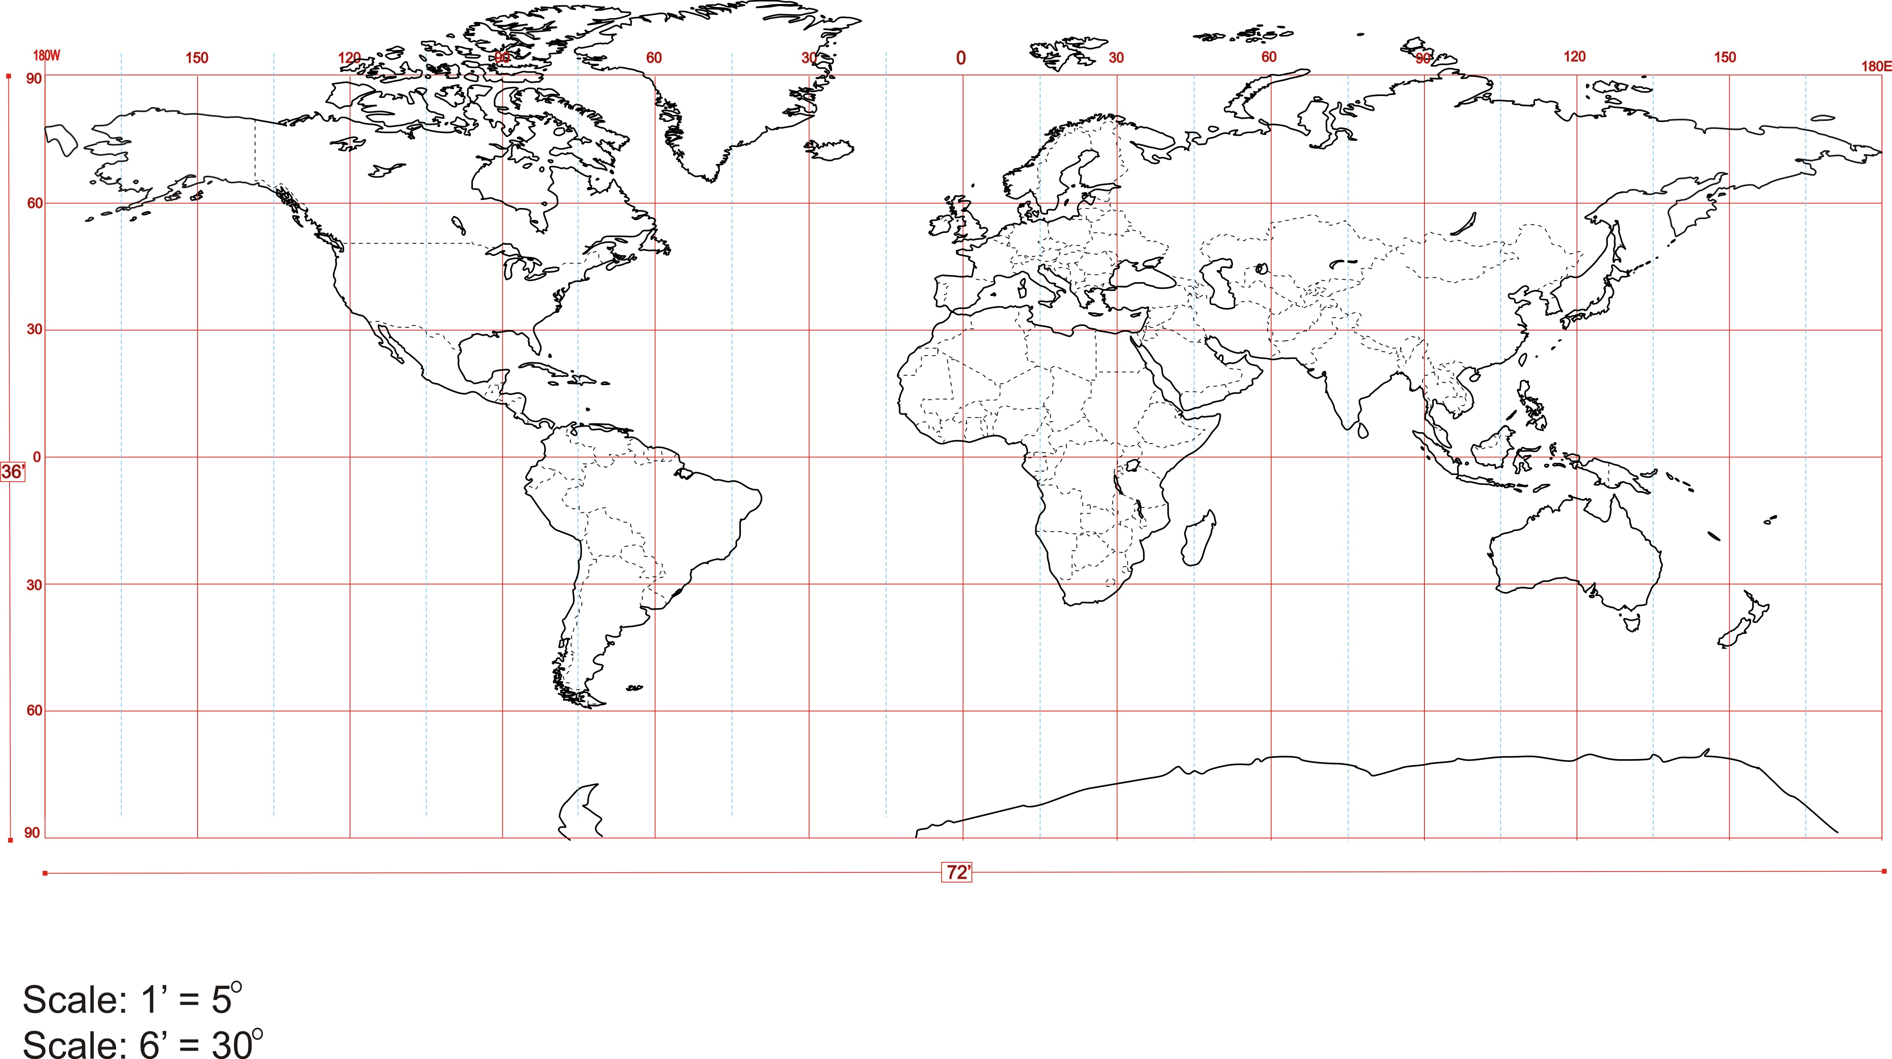

The Project Overview

Our class will construct a large Mercator map projection similar to the one above on area designated, using stakes, strings (Latitude & Longitude lines) & drawing the continents in chalk.

The project will begin with the construction of the prime meridian and equator lines.
Familiarize yourself with the map directions, NSEW, measurements and materials.

Your construction group is responsible for putting in specified lines using the strings, labeling the stakes and drawing an outline of a designated region on the outdoor map. The outline must be accurate in shape and location.
N.

Directions for Construction of Primary Reference Points
2.
1.
Begin by staking out the prime meridian line, starting at the southern most point (90º S, 0º EW) and continuing north (up) using the compass as an aid to follow on a straight course of direction.. Mark the northernmost point of the Prime Meridian. (90ºN, 0º EW) Establish the equator point using the measurements below. Put in the Equator line again using a compass to establish consistent direction.

Map Perimeters

Once the map equator and prime meridian are in place, measure the hemisphere height and width and establish the map perimeters.

Map size - 36’ height by 72‘ wide

The Northern Hemisphere is 18 feet in height
The Southern Hemisphere is 18 feet in height
The Eastern Hemisphere is 36 feet wide
The Western Hemisphere is 36 feet wide

Double check put in the map perimeters and make sure the map is “square” and that all measurements below are consistent at various points on the map. A laser beam measurer may also be employed.

Label all stake points so that these points are visible on the map

Latitude & Longitude Line Construction

Your group will construct lines using stakes and string. Assignment of lines to construct are specified on pages 3 & 4 of this handout.

Before you begin construction on the large map, color in the lines your group will construct on your project paper map.

As we begin work on the large stake & string map, measure and locate the correct locations for your stakes. Label the stakes in a manner such that the coordinates can be read while inside the map boundaries. Attach the string to the opposing stake with the same latitude or longitude. Make sure your strings are touching the ground. Construct the lines as follows.

Latitude lines
N & S of equator 3 feet is 15º latitude

Longitude lines
E &W of prime meridian every 3 feet equals 15º longitude

Once your stakes and strings are accurately in place, return the scissors, hammer, ruler (or tape measure) and red pen to the place where you found them.

Before you can draw your continent in chalk, all latitude and longitude string lines must be on the map You may have to wait until this process is completed. Once all of the latitude and longitude lines are in place your group will draw the region you have been assigned to outline. (see below)

Continent Outline Construction

Use your chalk to draw the continent outline on the lawn. Group discussion is STRONGLY encouraged before any chalk lines are placed. Thin heavy lines most often work the best. Your map must be accurate in shape and location. Double-check your work. Once the chalk outline is complete, go back over it several times to darken the line.

Construction Groups

**Please note you may be constructing lines in one location and outlining a continent region in a completely different area.

Group1 construct longitude lines in Eastern Hemisphere
15E, 30E, 45E, 60E & 75E
10 stakes
Label all 10 stakes
Chalk in outline of North America

Group 2. construct longitude lines in Eastern Hemisphere
90E, 105E, 120E, 135E, 150E & 165E
12 stakes -
Label all stakes
Chalk in outline of Middle & South America

Group 3. construct reference lines
Equator, Prime Meridian, 90S, 90N, 180E, 180W
12 large stakes
label all stakes
Chalk in outline of North Asia.

Group 4. construct longitude lines in Western Hemisphere
15W, 30W, 45W, 60W & 75W
10 stakes
label all 10 stakes
Chalk in outline of Europe

Group 5. construct longitude lines in Western Hemisphere
90W, 105W, 120W, 135W, 150W & 165W
12 stakes
label all 8 stakes & 180 E & W
Chalk in outline of Africa

Group 6. construct latitude lines in the Southern Hemisphere -
15S, 30S, 45S, 60S, 75S
10 stakes
Label all stakes
Chalk in outline of E Asia & SE Asia

Group 7. construct latitude lines in the Northern Hemisphere.
15N, 30N, 45N, 60N, 75N
10 stakes
Label all stakes
Chalk in outline of S.W. Asia, S. Asia & Oceania

