Name _______________________
Geography
Sierra College
Carol J. Cox

Course Time _________________

Due Date ____________________

EXERCISE #3
Atmospheric Layers/ Heat Transfer/ Temperature/ Isobar Map/
Lapse Rates/Wind Diagrams/Pressure Centers/Ocean Currents

1. ATMOSPHERIC LAYERS
Diagram the layers of the earth’s atmosphere as demonstrated in class. Label the location of the jet
stream and the ozone layer in the appropriate locations. Use of colored pencils is suggested.

What is the significance of the troposphere? _______________________________________________________

___________________________________________________________________________________________

2. HEAT TRANSFER OF ENERGY
Define and give examples of the following:

(a) conduction ______________________________________________________________________________

(b) convection ______________________________________________________________________________

(c) advection _______________________________________________________________________________

3. FAHRENHEIT AND CELSIUS TEMPERATURE CONVERSIONS
Using the formulas, convert the temperatures that are given:
C=5/9 (F-32) or (F-32) x .55 F=9/5 C + 32 or C x 1.8+32

(a) 72°F = ______ °C (d)10°C = _______ °F
(b) 32°F = ______ °C (e) -8°C = _______ °F
(c) 98.6°F = ______ °C (f) -40°C = ______ °F

4) ISOBARS

A map on the next page shows barometric pressure readings in millibars, all reduced to a sea level surface.

(a) Draw isobars for every three mb. e.g., 990, 993, 996, etc. Once your isobars are complete you will see
several centers of circulation. Label the high and low pressure cells.

(b) Draw arrows to indicate wind circulation from the high to the low.

(c) Place a heavy arrow along the steepest pressure gradient.

(d) In what general direction is the high pressure cell likely moving? _____________

(e) Interpret the map for conditions at your location (Grass Valley or surrounding area)

- Pressure __________________

- From which direction is the wind blowing from? ________________

- Is the barometer rising or falling? _________________

- Is the weather likely to improve or deteriorate? ________________

- Is the temperature, most likely rising of falling? __________________

5) NORMAL LAPSE RATES AND WET AND DRY ADIABATIC RATES
Determine the temperature at the top of the mountain if – there is no wind until 3000 ft and the level of the condensation is at 5000 ft.

7500 ft. summit Temperature ____________

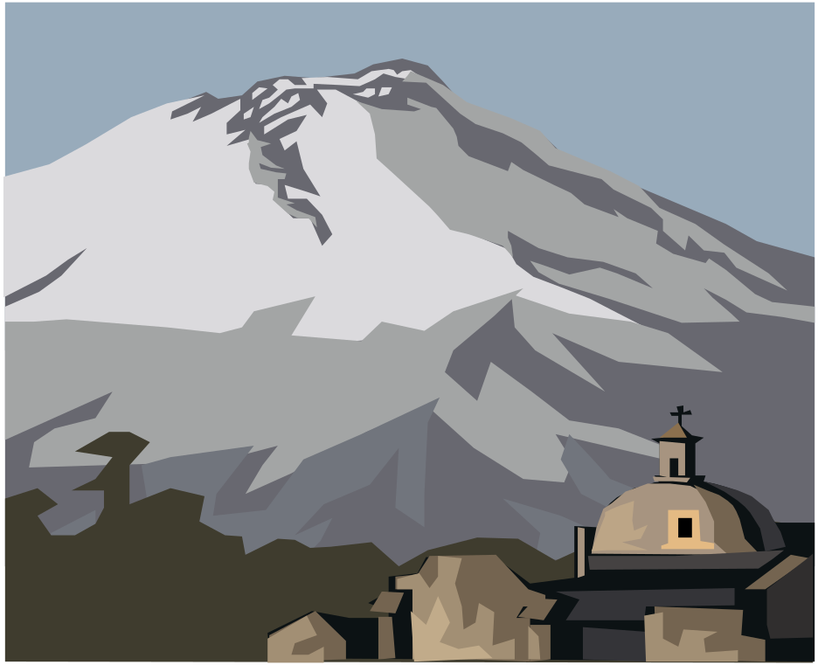

Sea Level

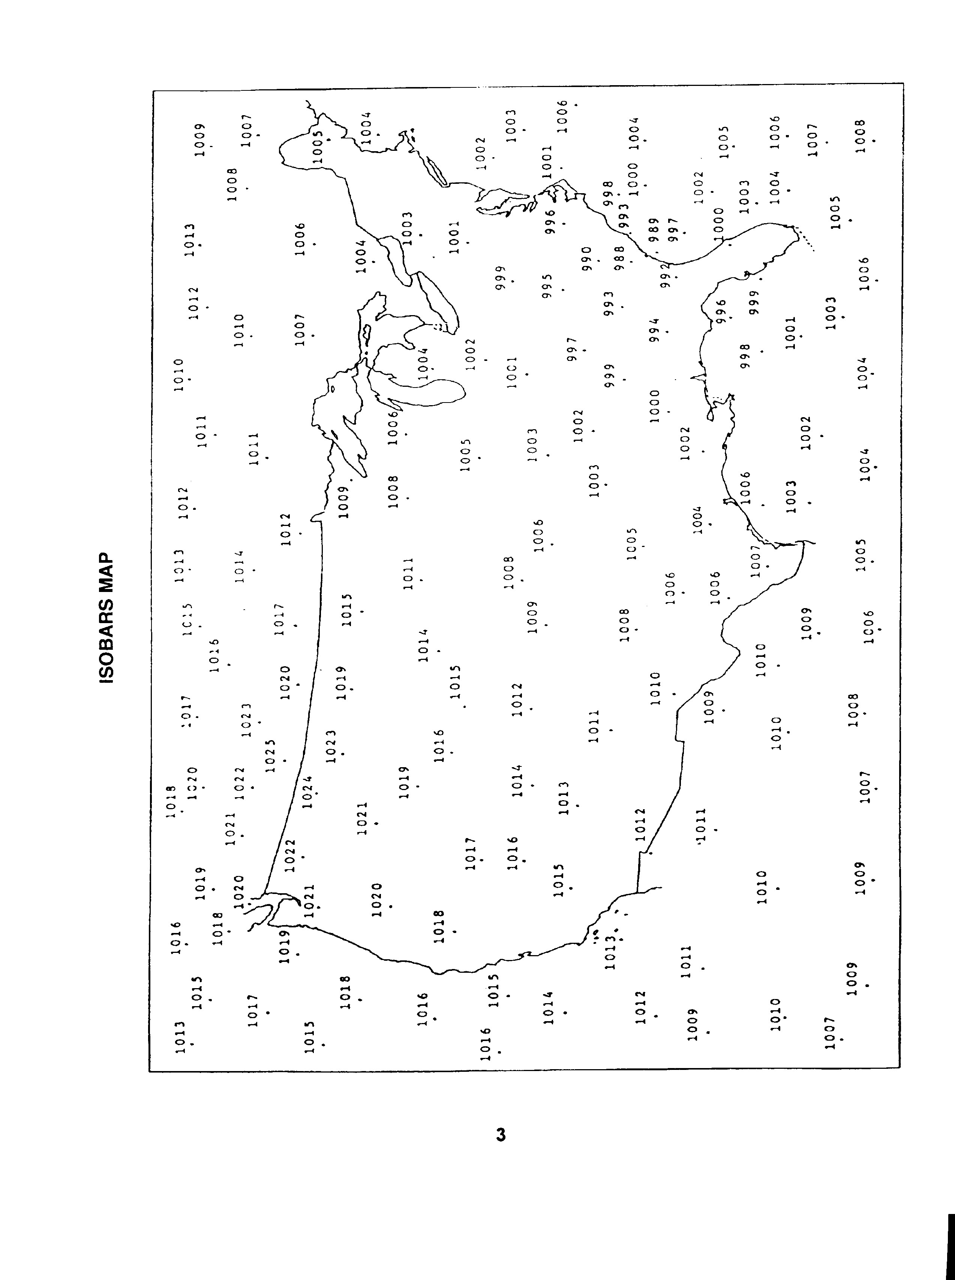
6. DIAGRAMMING WINDS
Draw the direction of the wind currents. You should indicate where high and low pressures are located.

D

FDESD
F7) PRESSURE BELTS AND WIND SYSTEMS

On the drawing below sketch in and label the earth’s pressure belts. Draw arrows for wind directions and label the wind belts. (This is a simplification of the earth’s planetary wind circulation but it does illustrate major tendencies. The idealized earth for this exercise is rotating, but it is considered to have a homogeneous surface; i.e., it disregards land and water contrasts.)

N

The sketch should include the following:

Pressure Belts Wind Belts Moisture Characteristics
Equatorial Low Westerlies Wet Belts
Subtropical Highs Northeast Trades Dry Belts
Subpolor Lows Southeast Trades
Polar Highs Easterlies

Diagram as shown in class (not the textbook)
Use colors to differentiate the different belts and add a key to your drawing.

Pressure Belts Wind Belts Moisture Characteristics
Equatorial Low Westerlies Wet Belts
Subtropical Highs Northeast Trades Dry Belts
Subpolor Lows Southeast Trades
Polar Highs Easterlies

Diagram as shown in class (not the textbook)
Use colors to differentiate the different belts and add a key to your drawing.

8) SEASONAL PRESSURE CENTERS

Because of the seasonal heating and cooling characteristics of land versus water, pressure centers develop over continents and ocean basins that tend to oppose one another. In winter, the colder land masses tend to be dominated by high pressure cells, and the warmer water bodies by low pressure cells. In the summer it is reversed. The air over the land masses is warmed more than the air over the oceans at comparable latitudes and the land masses are dominated by low pressure airs in the summer. These land and water contrasts are the principal complicating factors to the idealized system of planetary winds and pressure belts.

(a) On the world map below, locate and label the following pressure centers. Symbolize each center with two isobars.

(1) Siberian High (winter) (2) Canadian High (winter)
(3) Asiatic Low (summer) (4) Icelandic Low (winter)
(5) Aleutian Low (winter) (6) Azores High (Bermuda High) (year round shifts
(7) Hawaiian High (year round shifts with seasons)

(b) On the map draw arrows to indicate the seasonal reversal of the winds in the Asiatic monsoon system.
(1) Summer monsoon (red or broken arrows) (2) Winter monsoon (blue or solid arrows)

(c) Why are the idealized planetary winds and pressures less affected by seasonal changes in the southern

hemisphere than in the northern hemisphere? ____________________________________________________
___________________________________________________________________________________________
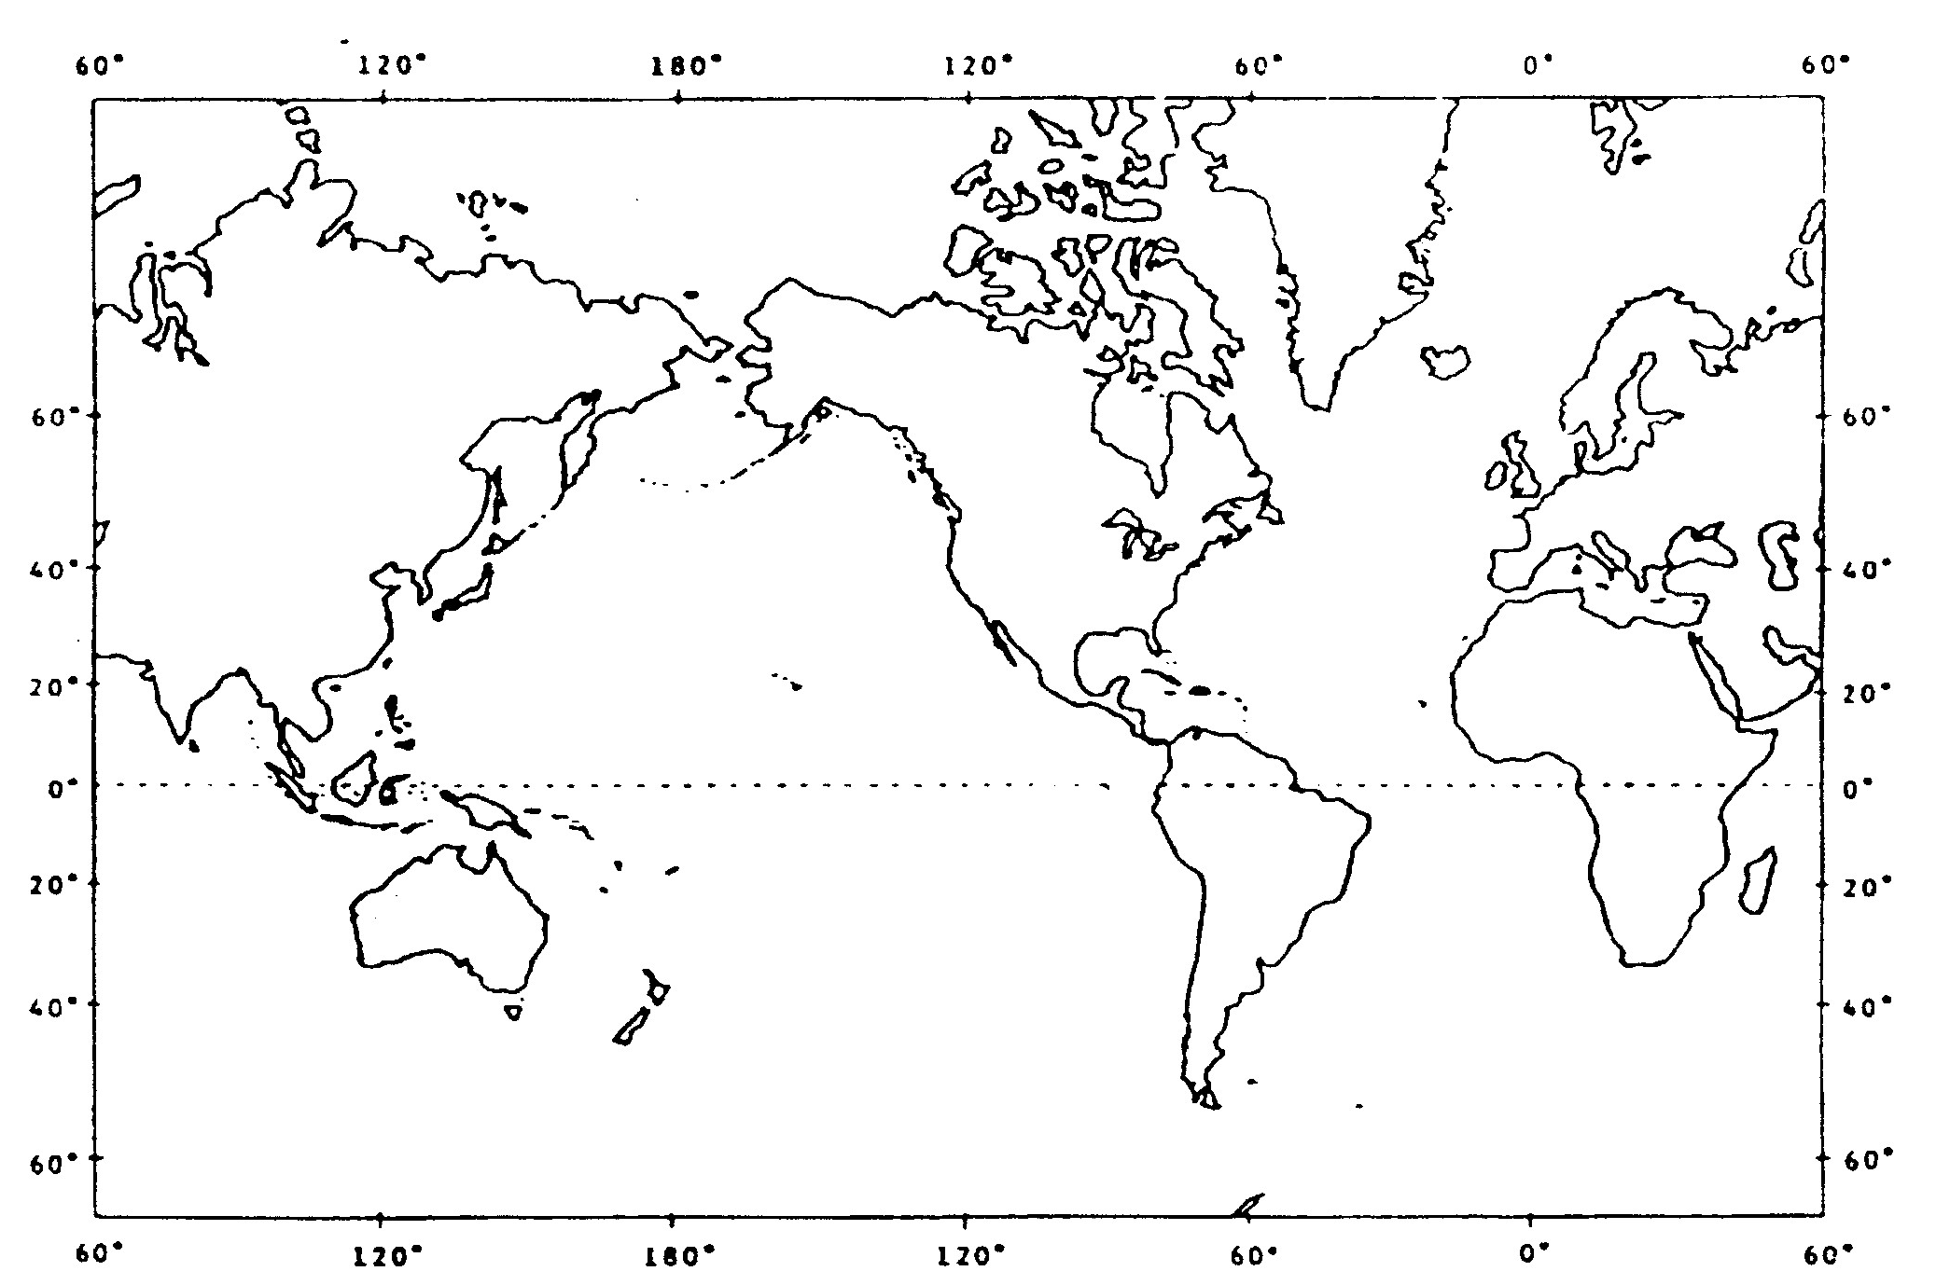
9) WORLD OCEAN CURRENTS

Ocean currents are primarily due to the friction of the air moving over the surface of the water. The topmost shallow waters tend to be dragged along with the prevailing winds. It is obvious when comparing the world patterns that close correspondence exists between the planetary winds and the major ocean currents.

a) Draw in and label the following currents on the large attached world map. Use red pen for warm currents and blue pen for colder currents.

b) As you draw these make a note to yourself where the currents are moving from and where they are flowing to. Explain the general directions of the ocean current movements. How do they move in each hemisphere and along the equator? What causes this? How do the currents redistribute global temperature?

___________________________________________________________________________________________

___________________________________________________________________________________________

The map must include the following:

(1) North Equatorial Currents (11) Kuroshio (Japan Current)
(2) South Equatorial Currents (12) North Pacific Current
(3) Equatorial Countercurrents (13) California Current
(4) West Wind Drift (14) Alaska Current
(5) Gulf Stream (15) Oyashio
(6) North Atlantic Drift (16) East Australian Current
(7) Canary Current (17) Humbolt (Peru) Current
(8) Labrador Current (18) West Australian Current
(9) Brazil Current (19) Agulhas Current
(10) Benguela Current (20) Monsoon Drift

c) Although the winds are the principal driving force behind the ocean currents, there are a number of other factors acting to cause movement of affecting direction of movement of the ocean waters. Describe at least three other factors.

(1)________________________________________________________________________________
_______________________________________________________________________________

(2) __________________________________________________________________________________

__________________________________________________________________________________

(3) __________________________________________________________________________________

__________________________________________________________________________________

10. WORLD ENVIRONMENTAL ATMOSPHERIC PROBLEMS

(a) Explain the depletion of the ozone layer. Explain what the ozone layer does. Explain the process in this depletion, the gases involved and the consequences of this depletion.

________________________________________________________________________________________________________________________________________________________________________________________________________________________________________________________________________________________________________________________________________________________________________________________________________________________________________________________________________________________________________________________________________________________________________________________________________________________________________

(b) What is the greenhouse effect?_____________________________________________________
__________________________________________________________________________________________________________________________________________________________

(c) What is global warming?__________________________________________________________
_____________________________________________________________________________
_____________________________________________________________________________

(d) How has man altered the natural greenhouse effect? Be sure to mention some of the greenhouse gases in your answer.
_____________________________________________________________________________
____________________________________________________________________________________________________________________________________________________________
_____________________________________________________________________________

