Name ______________________
Geography Sierra College
Carol J. Cox
Course Time ________________
Date Due ___________________

EXERCISE #2
Latitude & Longitude/Map Projections/Magnetic Declination
Longitude & Time/Township & Range/Contour Maps
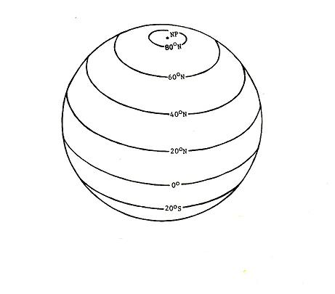

LATITUDE & LONGITUDE

1. (a) Sketch in and label the following
parallels of latitude:

(1) 35°N
(2) 10°S
(3) Tropic of Cancer
(4) Tropic of Capricorn
(5) Arctic Circle
(6) Antarctic Circle (Visible from this angle?)
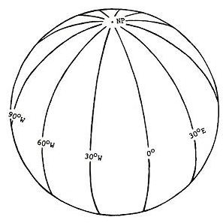

(b) Sketch in and label the following meridians of
longitude:

(1) 10°W
(2) 20°E
(3) 58°W
(4) 143°W
(5) 0°E, W (Prime Meridian)
(6) 180°E, W International Date Line)
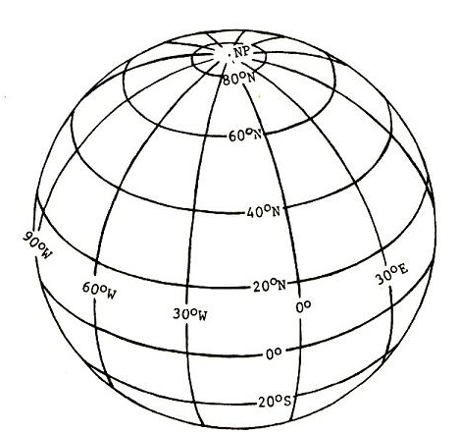

(c) Plot and number the following:

(1) 35°N, 90°W
(2) 10°N, 30°E
(3) 30°S, 10°W
(4) 80°N, 80°E
(5) 15°S, 20°E
(6) 10°N, 150°E

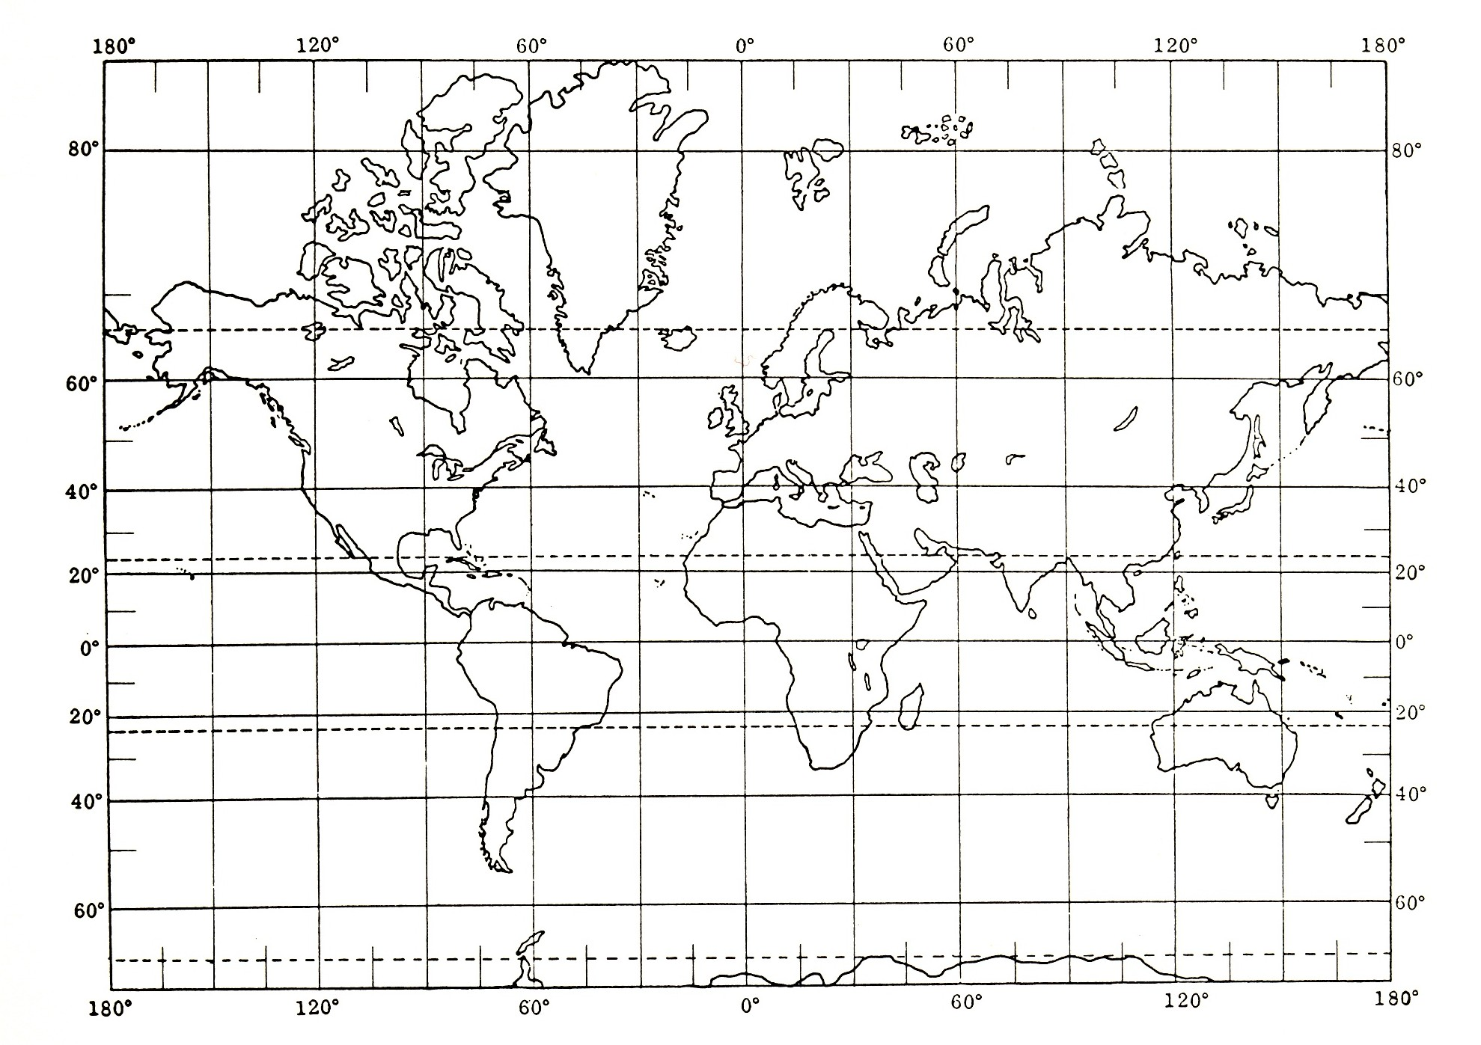

(d) On the Mercator projection above, plot and label the following positions:
(1) 35°N, 90°W
(2) 10°N, 30°E
(3) 30°S, 80°W
(4) 80°N, 80°E
(5) 15°S, 60°E
(6) 10°N, 150°E
(7) 20°N 105°W
(8) 52°S 23°E
(9) Shade in an area bounded by:
60°N, 30°E
45°N, 30°E
55°N, 90°E
MAP PROJECTIONS

2. (a) Diagram the three primary types of map projections. Label each drawing on the top set of lines and on the second set of lines explain what each projection is used for.

___________________ _______________________ ______________________

___________________ _______________________ ______________________

(b) What is a conformal projection? __________________________________________________

What does an Equal Area Projection show?
_________________________________________

DEGREES, MINUTES & SECONDS

3. Some of these geographic grid coordinates are written incorrectly. Some are correct. Determine those that are incorrect and write the correction immediately beneath. It is not necessary to locate these on a map.

- Lat. 27° 73’24”S, Long. 118° 16’34”W

________________________________________________________________________

- Lat. 66° 13’59”S, Long. 83° 43’66”E

________________________________________________________________________

- Lat. 43° 18’04”E, Long. 185° 10’00”W

________________________________________________________________________

(d) You may want to use a globe for the questions below.

- The point on the earth’s surface opposite 52°N latitude, 140°W longitude is

________________________________________________________________________

(2) You are located at 10°S latitude 10°E longitude; you travel 30° north and 30° east.
What are your new geographical coordinates?
_______________________________

(3) You are located at 40°N latitude, 90°W longitude. You travel due north 40°, then
due east 60°. What are your new geographical coordinates?
________________________
MAGNETIC DECLINATION

4. (a) Magnetic North is currently located at 76°N 102°W. Where is this?
(Specifically what country and what island)
______________________________________________

- Magnetic South is currently located at 68°S 145°E. Specifically where is this?
(Write the name of the island, water body, iceberg, etc.) ______________________________________________

- What is our location in exact terms? (latitude & longitude degrees) __________________

- What is our approximate magnetic declination? ________E or W? ___________________

LONGITUDE & TIME

5. (a) The Superbowl is being broadcast live throughout the world. The game starts in San Francisco at 1 p.m. PST, Sunday. What time would fans be able to watch it in:

Denver (Mountain Standard Time) ________________

Houston (Central Standard Time) ________________

Miami (Eastern Standard Time) ________________

London (Greenwich Mean Time) ________________

Hong Kong, China ________________ day? ________

Sydney, Australia ________________ day? ________

(b) Work the following time zone problems on the next page and write your answers below. It is important to show your work on page 5.

1. 5 p.m. E.S.T. Wed., = _____________ 135 degrees E (Japan)

2. 10 p.m. at 135 degrees E, Wed. = _____________ 120 degrees W (Sacramento)

3. 12 noon P.S.T., Wed., = _________________105 degrees E (Vietnam)

4. 9 p.m. P.S.T., Wed., = __________________ 30 degrees E (Moscow)

5. If you took a flight leaving Tokyo at 8am on Monday and arriving at Chicago at 6am on Monday, how long would the flight be?
___________ Hours of flight

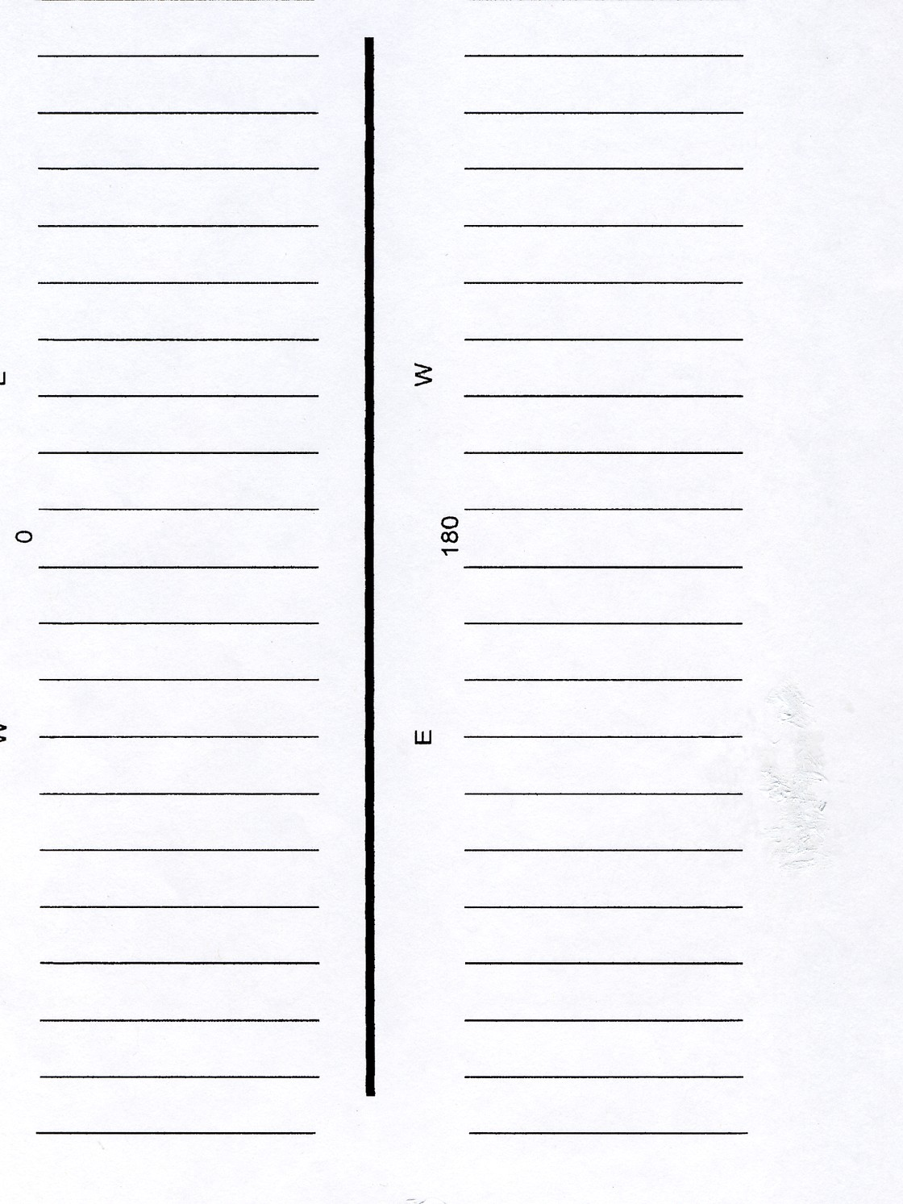
TOWNSHIP & RANGE LAND SURVEY SYSTEM

6. Based on the diagram below answer the following questions.

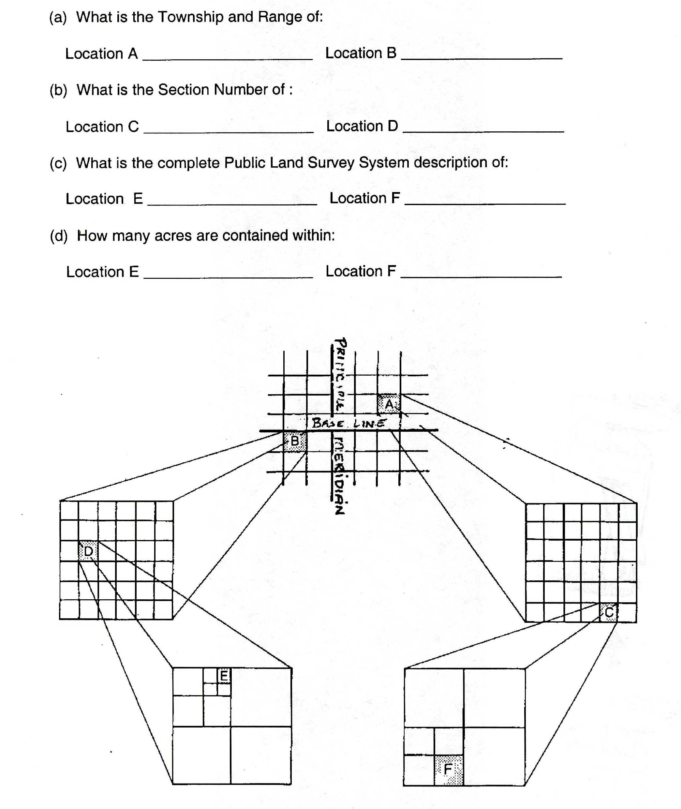

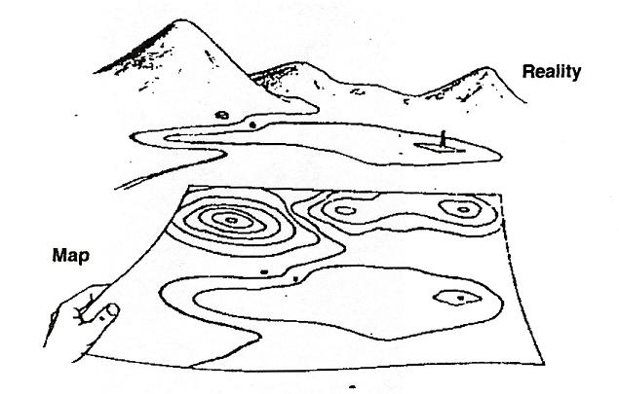

CONTOUR TOPOGRAPHICAL MAPS

7. Study the diagram above and the relationship between the contour map and actual topography (real elevation differences). Using the contour map on the next page answer the following in the space behind each question. Topographic symbols can be found in your textbook.

(a) Contour interval: (b) Elevation of point G:

(c) Elevation of point A: (d) Elevation of point B:

(e) Lettered point with highest elevation: (f) Lettered point with lowest elevation:

(g) Highest elevation on map: (h) Lowest elevation on map:

(i) Relative relief: (Highest to lowest point on the map)

(j) Which lettered point is in a valley?

(k) What is the elevation of the bottom of the depression?

(l) How deep is the depression?

(m) Written or verbal scale: (be exact – use a ruler)

(n) Ratio scale or representative fraction:

(o) Using the scales above, what is the exact distance from location B to D?



