Cultural Geography
Sierra College
C.J. Cox Instructor

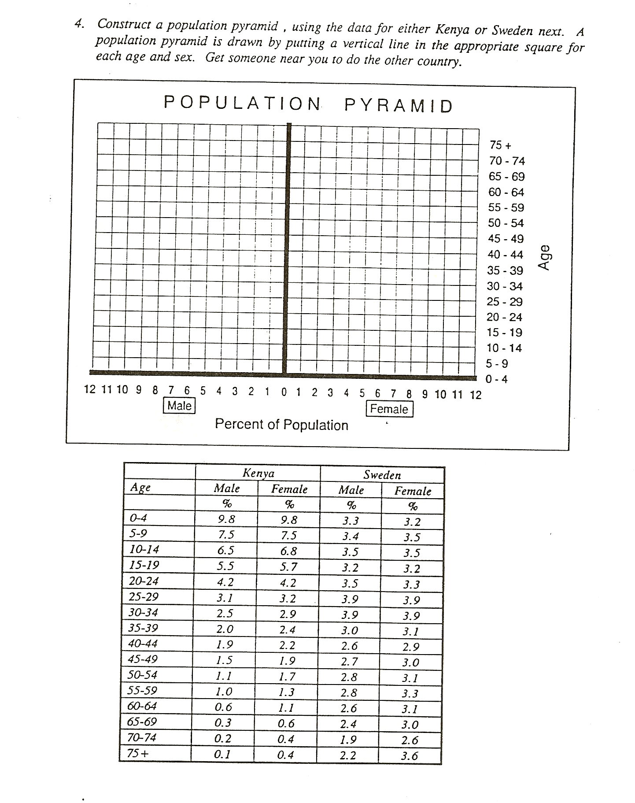
POPULATION PYRAMID EXERCISE

